

**Suicide in Venezuela. Humanitarian Crisis and Self-Inflicted violence[1]**

With emphasis on the states of Mérida and Aragua

**Introduction**

The estimated suicide[2] rate in Venezuela increased from 3.8 (2015) to 8.3 (2017) and 9.7 suicides per 100,000 inhabitants (100m/h) (2018), which led to an increase in their frequency in the order of 118 and 155%, respectively. This means a percentage increase between 2015-2017 and 2015-2018 in the occurrence of self-inflicted deaths, which would be around 132 and 153%, during those periods.

Despite the fact that, throughout the 20th century and approximately until 2014, Venezuela showed relatively low rates with respect to the world average (in average 10.5 suicides per 100m/h), in recent years that has changed, since the trend since 2015 is one of increase, and, between 2017-2018, there have been experienced the highest suicide figures known in the last 80 years of statistical records of this cause of death (1936-2014) in the country. Suicides have increased amid unprecedented social, economic, and political-institutional conflict in more than 200 years of republican history.

The purpose of this work was to deepen the knowledge of suicides in Venezuela in the midst of a deep humanitarian crisis[3] that is being experienced and has been aggravating since 2014. This situation could have acted as a triggering factor for a host of negative feelings and of anxiety and depression disorders, which, in turn, could be driving Venezuelans of different ages towards suicidal acts.

In order to better approximate its understanding, this research was proposed with two approaches: one quantitative and the other qualitative. The first focused on estimation, between 1950-2018, of a set of numerical indicators to know, analyze and understand the past, present and future behavior of the occurrence and frequency of suicides in Venezuela. By means of the second, the aim was, on the one hand, to get closer to understanding the social, family and individual context in which some individuals developed and interacted before committing suicide and, on the other, to understand the perception of different professionals in relation to different topics on the subject of suicide, as well as its appreciation of the probable increase in suicide in the national context and its possible correlation with the worsening of the current crisis.

**Methodology**

The quantitative approach was structured in four stages. The first one referred to the investigation and revision of information of a statistical nature on suicides in different documentary sources (1936-2014: yearbooks of epidemiology and vital statistics, statistical yearbooks of Venezuela, yearbooks of mortality; 2010-2016: estimated suicide rates by the World Health Organization [WHO]; 1950-2018: population projections; 2001-2017: Corposalud Mérida mortality database; 2014-2018: regional press review of newspapers Pico Bolívar and Frontera;). The second consisted of an evaluation of the quality of the information used, both the numerical data from the yearbooks and from Corposalud Mérida and the one obtained through the review of regional newspapers. Once the two previous stages were completed, a varied number of indicators related to the occurrence and frequency of suicides (third stage) were estimated: general and historical rates, differential rates according to age, sex, and age crossing and sex, and by municipalities; percentage proportions of different types, correlation coefficients, relations by quotient of probable patterns, among others. Similarly, for visual analysis, linear charts, bar charts, scatter diagrams, among others, were prepared. The fourth and last stage was related to the elaboration of a series of thematic maps, using as source the cartographic base of the political-territorial division of the country, prepared by the National Institute of Statistics (INE). The software used in the digitization of the maps was QGis version 3.8 and the final composition scale turned out to be 1: 7,000,000 for Venezuela and 1: 800,000 for the state of Mérida.

On its part, the qualitative approach was also addressed from four stages. The first was based on the review of various background research works at the local, regional, national and international levels, where the issue of suicide has been addressed. In this way, a fairly broad overview was obtained on various topics such as: conceptual bases associated with the subject of suicides; differential behavior of rates according to age and sex, methods used and mobile; risk and protective factors against the occurrence of suicides, among many others. All this information allowed a general understanding of the different questions that would later form the interview questionnaire to be raised. The second stage concerned the design of two questionnaires that were applied to the interviewees: relatives of suicide victims and professionals linked to the subject under study. Each instrument was conceived and adapted to the type of interviewee, since the information of interest to be obtained from family members and professionals was going to be totally differential.

It is necessary to mention that, on a regional scale, this research had the Mérida and Aragua states as spatial units of analysis. This is because, in the case of the first, it was possible to obtain statistical information on suicides until 2017 and also had the support of a group of professionals willing to provide information on the subject, through interviews. In the case of the second, the opportunity to study the problem posed arose from the presence of a group of experts trained in the health area, within the team responsible for said entity, which allowed the addition of more detailed interviews for the inquiry; however, in the state of Aragua the quantitative approach was not applied, due to not being able to access statistical information on suicides.

In total, twelve in-depth interviews were conducted, four with relatives of suicide victims and eight with professionals: three psychiatrists, two sociologists, a psychologist, a forensic pathologist and a public health specialist. The fourth and final stage, of office work, consisted of the fact that, once the information had been obtained in each interview, within the first 24 hours of carrying them out, the recordings of the conversations were listened to, and the transcription of what was exposed by the interviewees. This then allowed systematizing the information on the results and addressing their interpretation.

**Results**

Our estimates showed that, for 2017 and 2018, the absolute number of suicides in Venezuela could have reached between 2,648 and 2,889 cases, respectively. Taking into account the rate estimated by the WHO for the year 2015 (3.8 suicides 100m/h), nationwide, for that same year, some 1,143 self-inflicted deaths would have occurred, therefore, the percentage increase between 2015-2017 and 2015-2018 of the occurrence of those, should have ranged between 132 and 153%, in those periods. From the point of view of the rate, we project that it could have gone from 3.8 in 2015 to 9.7 suicides 100m/h in 2018, which means that it could have risen to a top value close to 155%.

There are many research works that have demonstrated in different countries of the world the relationship between moments of economic crisis and the increase in suicide rates. However, in the Venezuelan case, the problem goes beyond the economic and transcends a real and very tangible scenario of humanitarian crisis, characterized mainly by increased poverty and food insecurity, deterioration of public services, increased mortality, high inflation, destruction of employment and fall in national production, increase in violence and citizen insecurity, forced migration abroad, among other aspects. Therefore, dimensioning the impact that this negative situation has sowed in all those aspects in the social plane, has been possible thanks to the availability of information on the living conditions of the Venezuelan population from the ENCOVI[4] project. Therefore, it is probable that the frequency of self-inflicted deaths increases in view of the reality that Venezuelan society is currently experiencing, since there are also diverse investigations that have addressed and demonstrated the increase in mortality in nations that have suffered contexts of humanitarian crises and the rise in suicide rates has been no exception.

In the opinion of the majority of professionals interviewed in this research, it is likely that suicide rates have increased in Venezuela, and they correlate this escalation with the undeniable adversity that the country is going through. For them, individual and family situations, in the palpable and forceful absence of protective factors, are combined with a situation that serves as the main trigger for the increase in suicide cases in the national territory. They are of the idea that the Venezuelan crisis has become an anguish for many and has led to an increase in suicidal acts associated above all with depression and anxiety, as well as the increasingly common appearance of impulsive behaviors related to traumatic events, which have also led many to suicide or suicide attempt. Research has shown the strong connection between suicide and mental disorders such as depression, anxiety, bipolar disorder, in at least 80% of cases of self-inflicted[5] deaths. A conspicuous example of all of the above is represented by two of the stories investigated in this work, through consultation with relatives of victims of suicide (or attempts) and three others reported in the research carried out by Crespo (2019)[6]. The first of these was a 51-year-old man, who arrived at the act of suicide due to a sum of factors such as a sense of isolation, lack of social support, conflicts in the couple relationship and within the home, family predisposition to suicide, financial problems and depression, the latter two connected with deep concern about the national crisis. The second story was related to a suicide attempt by a 35-year-old woman, where the loss of her job, the lack of money for basic purchases, the illness and the fact of not being able to give everything she needed to Her 11-year-old son was combined with other factors such as a feeling of isolation, helplessness and loneliness, which led her to a depressive picture and attempt on her life.

Suicide in Venezuela went from being an individual decision related to different risk factors, to also being a social phenomenon. The precariousness of life has not only increased direct and structural violence throughout the national space, but also, the violence of individuals towards themselves.

In relation to other indicators obtained with the most recent statistical figures known (2014 Mortality Yearbook), we can say that, according to the differentiation by sex, of the total number of suicides that occur in the country per year, 83% of cases they correspond to men and the remaining 17% to women, while the suicide rate for men exhibits values that are five times higher than the indicator for women (on average between 3 and 1 suicide per 100 thousand/h of each sex, respectively). Regarding age, the highest occurrence of self-inflicted deaths occurs between 15 and 39 years (≈45% of the total), however, the highest rates are presented to older adults (65 years and over), that is, where it is more frequent the fact for every 100,000 inhabitants who, in this case, are elderly. With the crossing of sex and age, we can affirm that young adult men (20-29), adults (30-39) and the elderly (65 years and over), become the main victims of this cause of death.

When discussing the methods used by suicide bombers, the information from our study shows that hanging is the most widely used procedure in 52% of cases. Then followed by the use of firearms (27%), the intake of toxic substances (13%) and jumping from a high place (10%). A recent WHO[7] study on the subject pointed out that, for Venezuela, 62% of individuals who have made the decision to commit suicide have used the method of mechanical suffocation (hanging), followed by poisoning (21.2%) and the use of firearms in third place (12.6%). The remaining 4.2% is distributed between jumping from a high place, exposure to fire or flame, drowning or submersion, and cutting or puncture.

The latest official figures on the subject are those published by the INE in the 2003 Statistical Yearbook of Venezuela, and reported that 53% of all cases of self-inflicted deaths recorded by this institution, had their origin in affective, family and mental diseases. However, the current trend is towards an increase in the number of suicide cases where the presumed cause is mental disorders such as anxiety and depression.

Going into spatial differentiation, we find that the Mérida state is the entity with the highest average suicide rate (8.9 suicides 100m/h) in all of Venezuela between 1950-2014 and which historically turns out to be 2.03 times the country's historical rate (4.4 suicides 100m/h) and 102% higher than the latter (Figure 1). The closest follower is the Trujillo state (6.3 suicides 100m/h) and, even so, the Mérida rate is 1.4 times that of this other Andean entity (41% higher than the Trujillo value) and 6.3 times that of Vargas (1.4 suicides 100m/h), the territory with the lowest indicator (535% higher).

More specifically, the availability of more recent statistics in the context of the state of Mérida (period 2001-2017), provided by Corposalud Mérida, and the exhaustive review of the regional press (newspapers Pico Bolívar and Frontera, period 2014-2018), they allowed estimating a series of indicators, as in the case of Venezuela. This is how, in the Andean entity, the average estimated suicide rate between 2017-2018 was around 22 suicides 100m/h, a value that, according to our evaluations, had never been registered in the state at least in the last eight decades. As for the rates, that of Mérida men is between 3 and 4 times that of women (27 and 8 suicides 100m/h of each respective sex). Taking age into account, the highest values are found in adults (45-64) and older adults (65 years and over). Furthermore, men in those age groups continue to be the main victims of self-inflicted deaths.

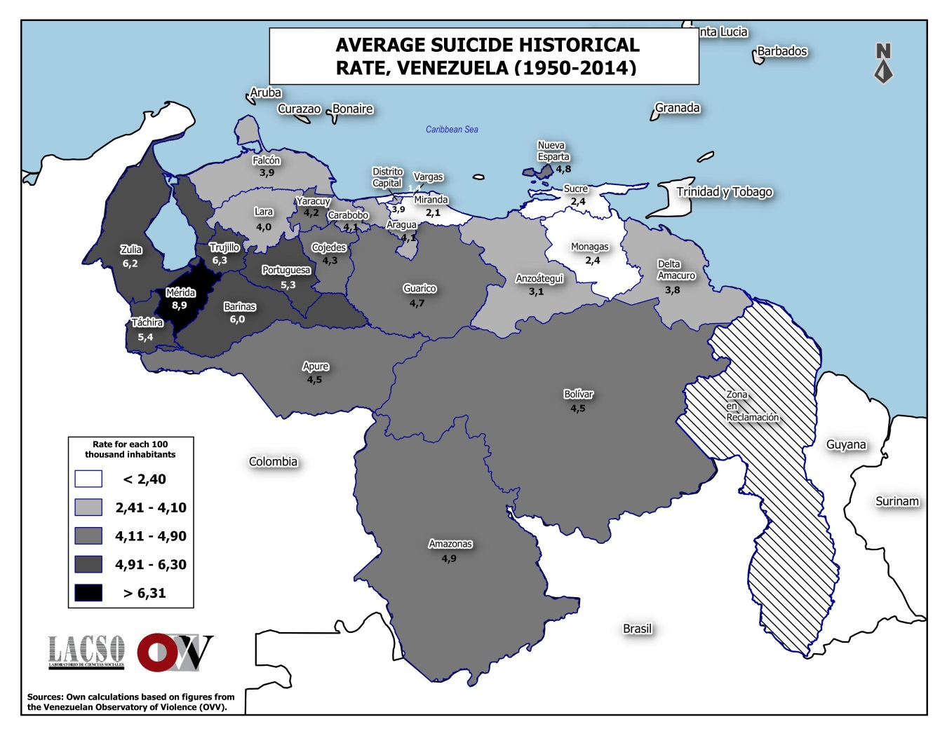

**Figure 1**. Spatial patterns of the historical suicide rate, Venezuela (1950-2014)

The motive is one of the most difficult aspects of studying suicide. This is because there are not many published statistics that can be achieved in this regard, much less at the state level. However, through a review of the regional press, as well as through consultation with the various specialists referred to in the preceding paragraphs, it was possible to determine that depression was the main motive for suicide deaths in the most recent years analyzed (2014-2018), within a sample of 216 cases whose motives were reviewed by journalists in that period; this went from a relative weight of 34.1 in 2014, to 58.8% in 2016. Then, even when it decreased a little, it remained above 56% in 2017 and 2018. Likewise, a similar pattern was found in the acts of suicide attempts. Of the total of attempts (225 referrals in the regional press) that occurred in the state of Mérida (2014-2018) whose motive was known (79 in total, 35.1%), depression, except in 2017, which showed 12.5 %, was in the first place within the causes. From the rest, it exhibited values of 29.4% (2014), 51.9% (2015), 66.7% (2016) and 50% (2018). These results are very consistent with those obtained from the interviews conducted in Mérida and Aragua, both with relatives of victims and professionals, who attribute them to conditions such as depression and anxiety, which in turn are linked to the country's humanitarian crisis.

From different spatial perspectives, the municipalities of Libertador, Alberto Adriani, Campo Elías, Sucre and Tovar, together, accounted for 73% of the total number of suicides that occurred between 2001-2017 in the Mérida state, all of an urban nature. In terms of suicide rates, the five municipalities with the highest values are Cardenal Quintero (17.7 suicides 100m / h), Pueblo Llano (16.1), Libertador (15.9), Santos Marquina (12.8) and Miranda (12.8) (Figure 2). In the rural area the rate was 10.6 suicides 100m/h, while for the urban it was 11.8; as can be seen, the value reached by the indicator in the city is higher than in the country. The region[8] with the highest rate turned out to be the Mérida Metropolitan Area with 13.8 suicides 100m/h. Then, the Páramo Zone (12.3), Mocotíes (10.1), the Pan-American Zone (8.6) and lastly the Pueblos del Sur (8.3) follow next in importance.

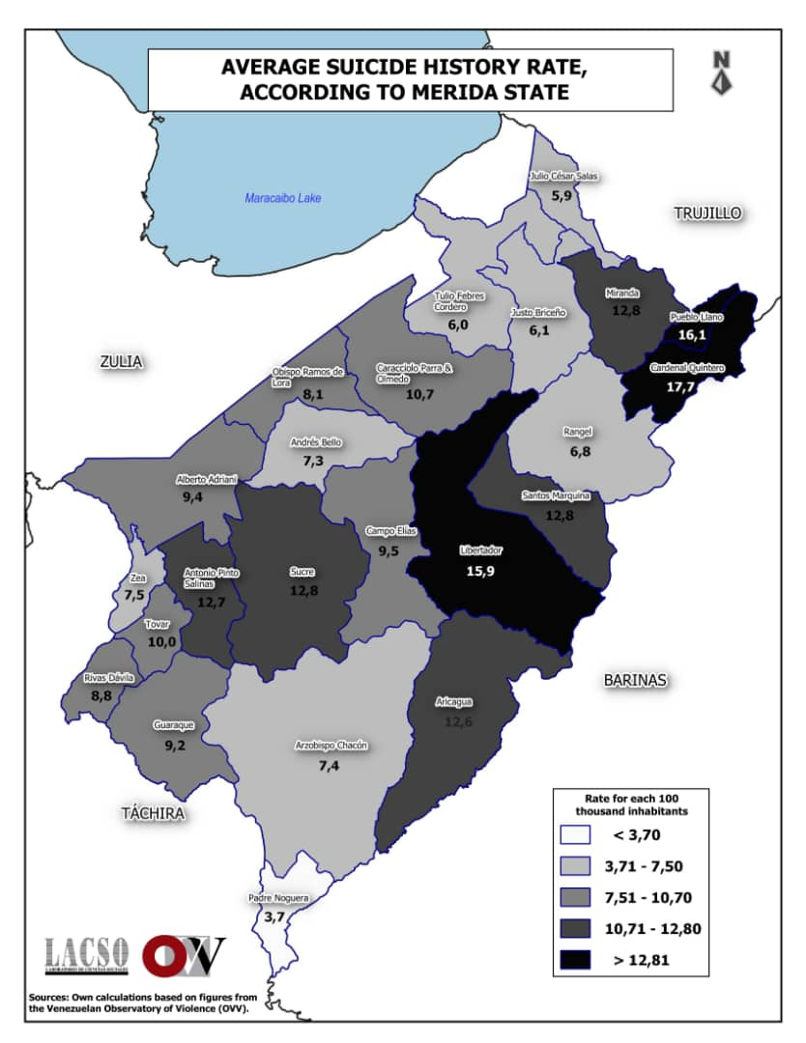

**Figure 2.** Spatial patterns of the historical suicide rate, municipalities of the Mérida state

(2001-2017)

On a different subject, it is necessary to say that the professionals interviewed offered a wide range of alternative proposals (protection factors) that would help to confront the subject under study, since this type of violent death has become a problem of public health in Venezuela. The specialists consulted from the Aragua state, on the one hand, focused their proposals on promoting changes in the thinking logic of today's society: promoting the cultivation of spirituality, differentiating it from religiosity; transcend the mercantile logic of modern hegemonic culture; strengthen the family structure and seek the meaning of life through the development of full sexuality and recreation. On the other hand, they presented approaches aimed at the quality of care for people with mental illnesses: at the public policy level, promoting the visibility of mental illnesses; raise awareness in the family regarding the limitations that this type of patients have, in the use of cognitive and emotional tools to resolve conflictive and/or problematic situations, among others.

From Mérida, the proposals were aimed at: (i) Providing guidance on the subject of suicide to students and to the community in general through talks aimed mainly at prevention. The problem of suicide must be learned to identify and the population must become aware of the situation; (ii) Provide information at the family level. That families understand that suicide is a serious issue and that it cannot be seen as many of them perceive it, that is, as only a wake-up call from people; (iii) The adoption and application of the mhGAP Intervention Guide (WHO version 2.0, 2015) for mental, neurological and substance use disorders at the level of non-specialized health care; (iv) The creation of support groups with the accompaniment of professionals (psychiatrists and psychologists) that help guide people who have attempted or intend to attempt suicide; (v) Preventive mental health campaigns must be carried out, as well as permanent public programs in this matter, since this topic is not considered at all in Venezuela; among other.

**Conclusions**

Suicide is a form of self-inflicted violence that depends on multiple risk and protective factors, which occur at the individual, family or community level. There is no single factor that explains the occurrence of suicide, because even people, often young and healthy, also decide to kill themselves.

The recent increase in the suicide rate (2017-2018) in the Mérida state is not a consequence of the uniqueness that this state maintained in terms of the occurrence and frequency of suicides for many years (1970-2014), but may represent a sample of what is happening in the rest of the national territory. However, at different rates of increase and numerical levels of rates, depending on the specific realities of each state. It is difficult to know for sure if Mérida, between 2015-2018, remained the region with the highest rate in the country, since there are no recent statistics from the rest of the entities to be able to make a comparison, as indeed it was did between the period 1950-2014.

Our hypothesis is based on the worsening of the crisis in Venezuela, characterized by impoverishment of society; the deterioration of families' protection capacities, the increase in domestic violence and conflicts in the homes associated with the lack of basic services, the difficulty in obtaining food, medicine and essential products, hunger and the certainty of food insecurity; the increase in the risks of death and retrogression in survival; regression in educational achievement; high increase in inflation, promotion of company closings, destruction of employment and fall in national production; increase in violence and citizen insecurity and forced migration abroad; they seem to be the most important risk factors that could explain the trend of increasing the suicide rate in the nation. Those are the factors that must have acted as triggers for the negative feelings that led many Venezuelans to make the unfortunate decision to kill themselves.

Venezuela, between 1936-2014, was characterized by relatively low suicide rates. However, since 2015 and, at least until 2018, according to the results of this research, there has been an increasing trend that has brought the figure closer to the world average, and even if that propensity continues, it could exceed it, because the rate doubled in that period and at most it could have tripled.

Our conclusion is that in the country, suicide rate registered between 2017-2018 have never seen before in the 80 years of statistical records of this cause of death.

**Summary tables of the most outstanding suicide indicators according to categories, Mérida state and Venezuela**

|  |  |  |  |  |  |  |  |  |
| --- | --- | --- | --- | --- | --- | --- | --- | --- |
|  | **Suicides** | **THS** | **Sex** | **Age** | **Sex and Age** | **Methods** | **Motives** | **Sources** |
| **Venezuela**  **(1936-1949)** | 2.165 | 3,7 | TH≈6,1-6,2  TM≈1,4-2,1  SH≈78,1%  SM≈21,9% | Most suicides happened on individuals younger than 30 years old (≈40-50%) | Men in all age groups except 10-14 and 15-19 show superior rates than women | The two principal methods used in this time where hanging and the use of a firearm | *** | Study on homicides and suicides in Venezuela, Ministry of Health and Social Assistance |
| **Venezuela**  **(1950-2014)** | 45.285 | 4,4    Maximum value reached: 7 suicides 100m / h (1965) | TH≈7,0  TM≈2,0  SH≈80%  SM≈20% | Before 30 years old happened nearly 40% of suicides | Nearly 45% of suicides happened between 15 and 39 years old. Rates grow towards the senior people | Continue as the most used methods hanging 52% and use of a firearm 27% | Family and passion issues together with mental disorders, they concentrate more than 50% of the suicides | Epidemiological and Vital Statistics Yearbooks, Mortality Yearbooks, Statistical Yearbooks of Venezuela, Population projections of the INE |
| **Venezuela**  **(2015-2018)** | Between the years 2017 and 2018, it is estimated that there were between 2,648 and 2,889 suicides in the country | It went from ≈ 3.8 to 9.7; that is, 155% increase | TH≈10,0  TM≈2,0  SH≈80%  SM≈20% | Trend of increasing rate rates towards the adults (45-64) and senior people (65 years and over) | Trend of increasing rate in both sexes towards the adults (45-64) and senior people (65 years and over) | Most used methods are: hanging (62%) and poisoning (21%) | Depression and anxiety, triggered by the current crisis, are shown as the main presumed causes in more than 50% of cases | Own estimates based on WHO figures, Mortality Yearbooks and data from Corposalud Mérida. Estimates of WHO suicide indicators, information from the media and that obtained from the interviews |

THS: Historical suicide rate for the period per 100,000 inhabitants

TH: Male suicide rate for every 100,000 same-sex inhabitants

TM: Female suicide rate for every 100,000 inhabitants of the same sex

SH: Percentage of suicides in men

SM: Percentage of suicides in women

*** The information is not available

|  |  |  |  |  |  |  |  |  |
| --- | --- | --- | --- | --- | --- | --- | --- | --- |
|  | **Suicides** | **THS** | **Sex** | **Age** | **Sex and Age** | **Methods** | **Motives** | **Sources** |
| **Mérida**  **(1936-1949)** | 120 | 3,9 | *** | *** | *** | *** | *** | Study on homicides and suicides in Venezuela, Ministry of Health and Social Assistance |
| **Mérida**  **(1950-2014)** | 2.949 | 8,9  Historic suicide rate of Mérida is 2.03 times the rate of Venezuela | TH≈15,5  TM≈4  SH≈75%  SM≈25% | In 1950, 40% of suicides occurred between ages 15-24. In 2014 39% of those deaths occurred in the group of 25-44 | In the 1950s men aged 15-44 accounted for 60% of deaths from suicide. In 2014 56% of those deaths occurred between the ages of 25-64 | The most used methods are: hanging (55%) jumping from a high place (21%) and poisoning (20%) | Family problems, sentimental and those related to the scope of university study, were the main causes | Epidemiological and Vital Statistics Yearbooks, Mortality Yearbooks, Statistical Yearbooks of Venezuela, Population projections of the INE |
| **Mérida**  **(2014-2018)¹** | 651  in just 5 years, the equivalent of 22% of total suicides occurred in the previous 65 years | 14,0    Average rate (2017-2018) ≈22 It went from ≈ 12 to 22; that is, 83% increase | TH≈27  TM≈8  SH≈80%  SM≈20% | In the 45-64 group occurred between 24% (2014) and 50% (2018) of suicides. Previously most suicides occurred at ages 15 to 29. Rate "aging" trend | Trend of increasing rates in both sexes towards senior people (45-64) and older adults (65 and over) | The most used methods are: hanging (58%) poisoning (29%) and firearms (7%) | Depression and anxiety, triggered by the current crisis, are the main suspected causes of suicide. Depression was present between 34% 2014 and 56-59% 2017-2018 of cases | Own estimates based on figures from Corposalud Mérida, information from the media and that obtained from interviews, Population projections from the INE |

THS: Historical suicide rate for the period per 100,000 inhabitants

TH: Male suicide rate for every 100,000 same-sex inhabitants

TM: Female suicide rate for every 100,000 inhabitants of the same sex

SH: Percentage of suicides in men

SM: Percentage of suicides in women

*** The information is not available

¹ In the particular case of Mérida, the estimations of the indicators were made for the period 2014-2018, unlike the case of Venezuela, which in this chronological stage corresponded to the period 2015-2018.

1. This writing is an executive summary of the extensive report derived from an investigation, entitled: “An approach to the study of suicide in Venezuela”, which was developed between October 2019 and March 2020. The work team was made up of Gustavo Páez (Geographer and Research Coordinator), Karina Rondón (Geographer), Yhimaina Trejo (Geographer), Jesús Boada (Geographer), Nilsa Gulfo (Journalist), Iris Terán (Surgeon), María Chacón (Bioanalyst), Solange Chacón (Teacher) and Kyra Liendo (Journalist).
2. According to the World Health Organization (WHO), suicide is the act of deliberately killing oneself where this type of death is also known as self-inflicted deaths WHO. (2014). Suicide prevention: a global imperative. Regional report. Washington, DC: World Health Organization and Pan American Health Organization. Available at: https://apps.who.int/iris/bitstream/handle/10665/136083/9789275318508_spa.pdf&ua=1?sequence=1
3. “A humanitarian crisis is understood as a situation in which there is an exceptional and widespread threat to human life, health or subsistence. Such crises usually appear within a situation of prior lack of protection where a series of pre-existing factors (poverty, inequality, lack of access to basic services), potentiated by the trigger for a natural disaster or armed conflict, multiply their destructive effects »CAÑADAS, M., Carames, A., Fisas, V., García, P., Prandi, M., Redondo, G., Royo, J., Pascual, E., Urgell, J., Villellas, A. and Villellas, M. (2010). Alert 2009. Report on conflicts, human rights and peace building. Icaria Editorial / Escola Cultura de Pau, UAB. Available at: <https://reliefweb.int/sites/reliefweb.int/files/resources/ED5A9D605ABE6AB3C12575DD002C6D66-SCP_Jan2009.pdf>
4. The ENCOVI project arose in 2014, from an alliance with researchers from the Catholic Universities Andrés Bello (UCAB), Central de Venezuela (UCV) and Simón Bolívar (USB), to face the government siege on official sources of information. Browsing through the web portals of the institutions responsible for generating economic and social statistics shows that, in terms of information, they were frozen in the years 2012-2014. Within this project, coordinated by the Institute of Economic and Social Research of the UCAB, five national surveys have been carried out to investigate the living conditions of the Venezuelan population.
5. Just to name a few: ECHEBURÚA, E. (2015). "The multiple faces of suicide in clinic psychology". Psychological Therapy, 33 (2), pp. 117-126. Available at: https://scielo.conicyt.cl/pdf/terpsicol/v33n2/art06.pdf; BERTOLOTE, J. and Fleischmann, A. (2002). "A global perspective in the epidemiology of suicide". Suicidology, 7 (2), pp. 6-8. Available at: https://www.iasp.info/pdf/papers/Bertolote.pdf
6. CRESPO, F. (2019). "Descriptive approach to the phenomenon of suicide in the state of Mérida, Venezuela". URVIO, Latin American Journal of Security Studies, (24), pp. 167-185. Available at: https://revistas.flacsoandes.edu.ec/urvio/article/view/3731/2630
7. WHO. (2014). *Suicide mortality in the Americas. Regional report. Washington, DC: World Health Organization and Pan American Health Organization. Available at: https://www.paho.org/hq/dmdocuments/2014/PAHO-Mortalidad-por-suicidio-final.pdf*
8. The regions into which the state of Mérida has traditionally been subdivided are: Mérida Metropolitan Area (Libertador, Campo Elías, Sucre and Santos Marquina municipalities), Páramo Zone (Cardenal Quintero, Pueblo Llano, Miranda and Rangel municipalities), Mocotíes Zone (Tovar, Antonio Pinto Salinas, Rivas Dávila and Zea municipalities), Pan-American Zone (Alberto Adriani, Obispo Ramos de Lora, Andrés Bello, Tulio Febres Cordero, Caracciolo Parra and Olmedo, Justo Briceño and Julio César Salas municipalities) and the Pueblos del Sur (Guaraque, Arzobispo Chacón, Aricagua and Padre Noguera).